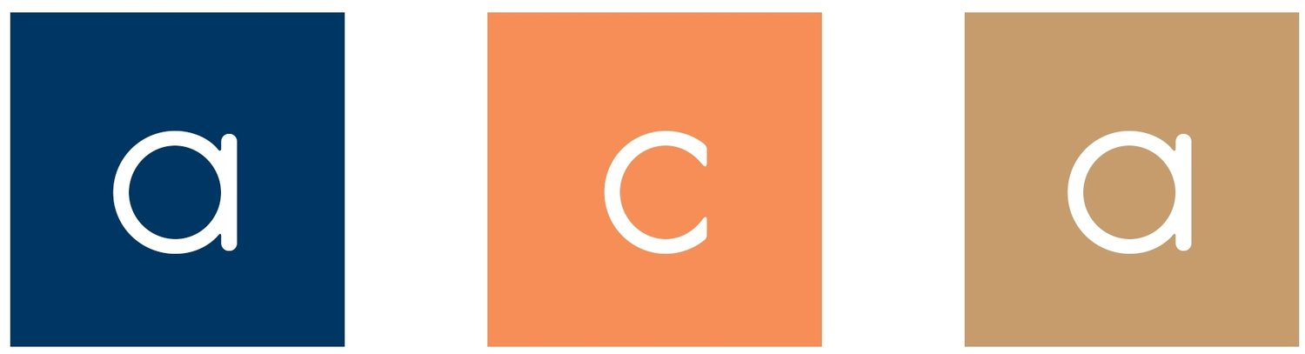

Association for Communication Administration
Business Meeting
Saturday, November 10, 2018
12:30-1:45 pm
Hilton, Salon III (Lobby Level)

Agenda

- Approval of the 2017 Business meeting minutes
- President’s Report- Helen Sterk
- Vice-President’s Report—Sarah Stone Watt
- Treasurer’s Report-Jeanne Persuit
- Journal Report-Janie Harden Fritz
- Legislative Assembly Report-Helen Sterk
- Elections-Helen Sterk
- Passing of the Gavel
- Announcements

