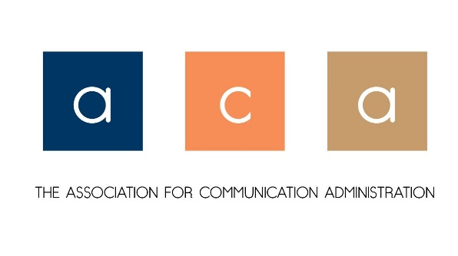
Business Meeting Minutes
Saturday, November 19, 2022
New Orleans, LA

- Welcome
- M/S/P Minutes from 2021

- Officer Reports
  - President’s Report – Dr. Laurie Diles
    - ACA Membership – we have 157 members
    - Christy McDowell and Patric Spence
  - Past President’s Report – Dr. Christina McDowell
    - Legislative Assembly Report – LA on Wednesday and Saturday
      - Move toward a “data-driven organization”
      - Financial report brought up a number of conversations: Myth 1: we are a wealthy organization, but NCA has been running on a deficit for 7 years Myth 2: We are broke, the operating budget is separate from the investment budget Myth 3: We make money off the convention. We do not and they have not reviewed a membership fee raise in a long time
      - Fundraising ability- will cost significant money; how will businesses partner, institutions partner
      - NCA and housing NCA HQ – it’s been renovated and they have a carriage house and they’re looking at how they can have events at the carriage house that would bring in revenue
      - Strategic Plan – LA Approved the NCA Strategic Plan AND the IDEA Strategic Plan
      - Presidential Citations, Second VPs – balloting will open Dec 1 and close Dec. 31
      - Leadership Development Committee election, discussion about the IDEA consultants and a high level of what the survey discussed
      - Communication Anxiety/Apprehension Division was reinstated
      - Spring LA session virtually
    - 2022 Shawn Long Outstanding Administrator of the Year was awarded to Dr. Sarah Stone Watt, Pepperdine University
    - Recognition of Helen Sterk and Chris Lynch for leadership – they will be receiving a gift card and certificate
    - Recognition of Dr. Janie Harden Fritz for her service as JACA Editor

  - Vice President’s Report on 2022 Conference – Dr. Laurie Diles reporting for Dr. Steve Hunt
    - Allotted 2 slots one is business meeting
    - 3 Competitive papers, reviewers declined to panel
    - Thank you to reviewers - Dr Nathan Carpenter, Lance Lippert, Sarah Stone Watt, Jeanne Persuit, Christy McDowell
    - 5 panel submissions – chose one
    - The Chair’s Forum, which NCA shares with ACA gave us an additional slot

  - Treasurer’s Report – Dr. Jeanne Persuit
    - See below
    - Ideas for revenue
  - Guest – Jeannetta Sims, University of Central Oklahoma, second VP candidate
  - Journal Editor’s Report
    - Christy McDowell is Editor, Dr. Spence is our Associate Editor

- ACA Elections Openings
  - Bob Becker is our new VP/Planner
  - M/S/P for Roy Schwartzman to be an At-Large Director
  - Communication Director discussion; call forthcoming

- New Business
  - None

Meeting Adjourned at 11:51 AM CST

Legend for Motions
M - Motion S - Second P - Pass
F - Failed W - Withdrawn A - Amended

Association for Communication Association
Treasurer’s Report
November 2022

Starting Balance: ACA TD Bank Checking Account Balance as of November 2022: $16,267.45
2022 Expenses
Website:
March 2022: $216.00 Yearly Squarespace Subscription
March 2022: $20.00 Domain Name Purchase (for integration with MailChimp)
June 2022: $16.00 Domain Name Purchase
Monthly: $6.00 Google Workspace (for commadministration email use) (Since November 2020)
Total Website Expenses November 2021 – November 2022: $324.00

NCA 2022:
November 2022: $100 Award Winner check
November 2022: $150.00 Recognitions
Total NCA 2022 Expenses: $250.00

Total 2022 Expenses: $574

ACA TD Checking Account Balance November 19, 2021: $16,267.45
ACA TD Checking Account Balance November 16, 2022: $15,693.45

Respectfully submitted,

Jeanne M. Persuit, Ph.D., Treasurer, ACA

