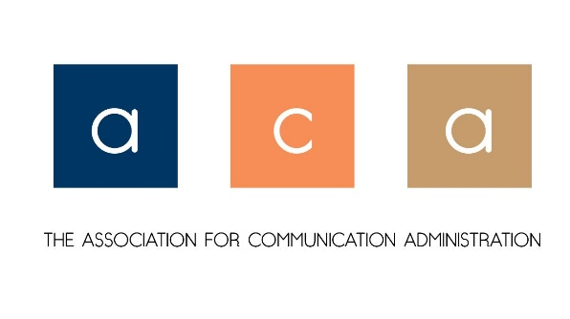
Business Meeting Minutes
Friday, November 19, 2021
Seattle, WA

- Welcome
- M/S/P Minutes from 2020

- Officer Reports
  - President’s Report – Dr. Christina McDowell (reported by L. Diles)
    - ACA Membership – we have 157 members
  - Past President’s Report – Dr. Sarah Stone Watt
    - Legislative Assembly Report –
- Adoption of the 2022 proposed budget – Approved
- New Journal Proposal, Communication and Race – Approved
- New Council Proposal, Mentorship and Leadership Council – Approved (Approval allows for the bylaws to be amended to include the council. The chair of the council will be added as a member of the Executive Committee and Legislative Assembly)
- New Interest Group Proposals
- Caribbean Communication Caucus – Approved
- SWANA Caucus (South West Asian/North African and Middle East) – Approved
- New Affiliate Proposals
- The Comics Studies Association – Approved
- The Institute of General Semantics – Approved
    - 2021 Shawn Long Outstanding Administrator of the Year was awarded to Dr. Bryant Keith Alexander, Dean of the College of Communication and Fine Arts and Interim Dean of the School of Television and Film at Loyola Marymount University

  - Vice President’s Report on 2021 Conference – Dr. Laurie Diles
    - 10 panels and 2 papers – (one was given to another unit)
    - Allocation of 2 slots, one of which would have to be the business meeting
    - We elected to have the 7:00 a.m. business meeting time in order to give 2 panels opportunity to present
    - The Chair’s Forum, which NCA shares with ACA gave us an additional slot
    - Total – 2 panels, the forum, and the Business meeting

  - Treasurer’s Report – Dr. Jeanne Persuit
    - See below
  - Journal Editor’s Report – Dr. Janie Harden Fritz
    - Latest journal issue is being finalized
    - Holding the top article award for next year and award 2020 and 2021
    - Any ideas for articles or blogs – take those and submit for review

- ACA Position Openings
  - Vice President (2022 Planner/President-elect) – Dr. Stephen Hunt accepted the nomination and was appointed as the position was uncontested.
  - Two At-large Board Members (3-year term) – Dr. Carl Cates and Dr. Jimmie Manning accepted nominations and were appointed to the uncontested positions.

V. New Business

- M/S/P to recognize Christina McDowell for her work leading during this difficult year, and Sarah Stone Watt for serving as president and past president and past-past president!

Meeting Adjourned

Legend for Motions
M - Motion S - Second P - Pass
F - Failed W - Withdrawn A - Amended

Treasurer’s Report
November 2021

Starting Balance: ACA TD Bank Checking Account Balance as of November 2020: $17,801.92
2021 Expenses
Website:
March 2021: $216.00 Yearly Squarespace Subscription
March 2021: $20.00 Domain Name Purchase (for integration with MailChimp)
June 2021: $16.00 Domain Name Purchase
Monthly: $6.00 Google Workspace (for commadministration email use) (Since November 2020)
Total Website Expenses November 2020 – November 2021: $324.00

NCA 2021:
November 2021: $1000 Business meeting catering
November 2021: $100 Award Winner check
November 2021: $110.47 Award Plaque
Total NCA 2021 Expenses: $1210.47

Total 2021 Expenses: $1534.47

ACA TD Checking Account Balance November 19, 2021: $16,267.45

Respectfully submitted,

Jeanne M. Persuit, Ph.D., Treasurer, ACA

